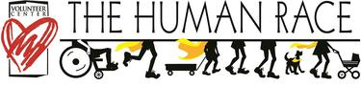
Empowered Girls of North Carolina
Love to run/walk? Join our race fundraiser or donate!
Join us for the 2019 Human Race April 18, 2020, sponsored by Empowered Girls of North Carolina Parent Initiative to raise funds for our 2020 Summer Camp. We appreciate your support in doing that.
Location: LeBauer Park
JOIN THE WALK/RACE - raise funds or MAKE A DONATION
The Human Race is a 5k Walk and Run managed by The Volunteer Center. Each year, the race supports about 100 different nonprofits.
You can Walk, Run or Roll to Support Empowered Girls of NC's programming for girls
Interested in starting a race team under Empowered Girls?
Please share with others!
Thank you!

